Doubt-1:- Here on the below screen shot, when we do any some modifications on the file and we wont commit at till doing commit it will on red colour (you said that its in danger stage danger means what). while we are in middle of the code editing out of 500 lines I did 150 lines with out saving the file. all of sudden my system got crashed / power failure etc happens means what will happen to that file? Will it still saved on stage?

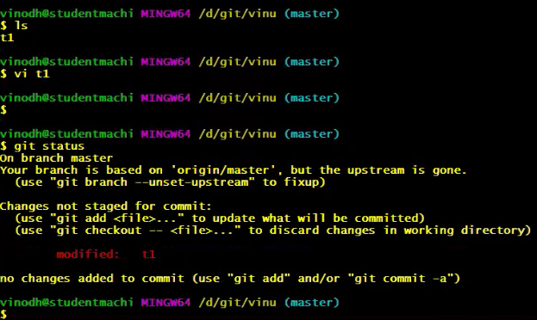

Doubt-2:- If we use this command on on directory then it removes all the file contents on that directory means what will happen?

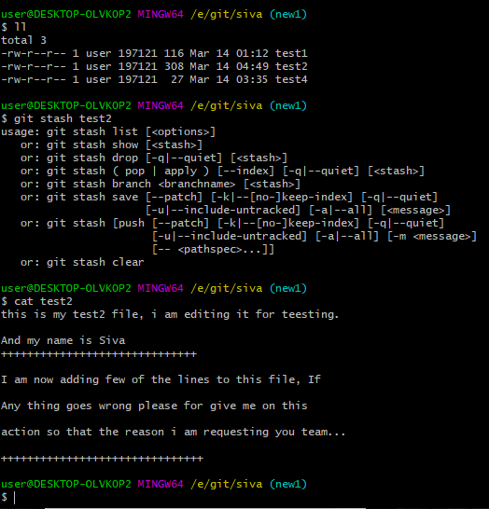

Doubt-3:- On the below screen shot I delete the 2 files & I commited them, when I use git reset means they are coming back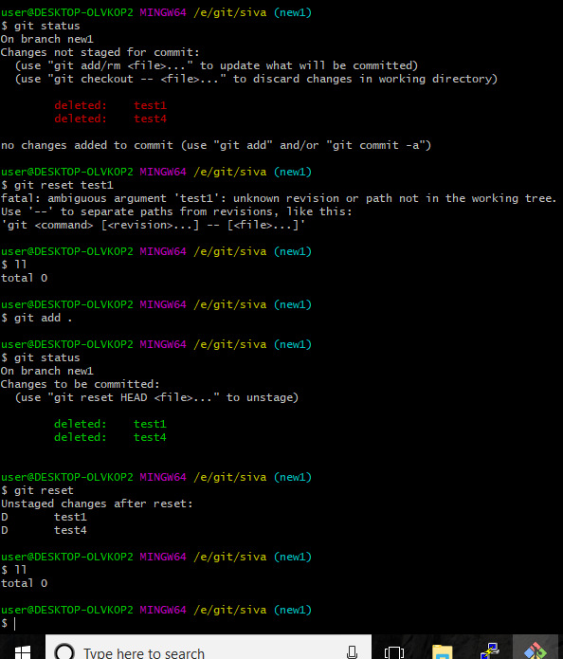

Doubt -4 :- When I try to establish the connection to Git hub it showing this Error. But the same account I am login to Git Hub

